HUZAR API

Document version: 2.75
Date: 13.05.2025

Table of contents
1. Document information 6
2. Changelog 6
3. Terms used in this document 6
4. HuzarAPI installation 8
4.1. HuzarAPI configuration 8
4.2. WinSAD Service configuration 10
4.3. Running WinSAD as a service 12
4.4. HuzarAPI installation test 12
5. HuzarAPI for SADs and temporary storage with http protocol 13
5.1. Methods using http GET 13
5.1.1. GETSAD 13
5.1.2. GETSADSTATUS 13
5.1.3. COPYSAD 14
5.1.4. GETSADBYRANGE 15
5.1.5. GETATTACHEDDOCLIST 16
5.1.6. GETATTACHEDDOCDET 17
5.1.7. GETCUSTOMSMSGLIST 17
5.1.8. GETGENERATEDDOCLIST 18
5.1.9. GETREPRESENTATION 18
5.1.10. GETDELIVERIES 19
5.1.11. SENDSAD 19
5.2. Methods using http POST 20
5.2.1. ADDSAD 20
5.2.2. ADDDELIVERY 21
6. HuzarAPI z protokołem HTTP dla modułu SENT 21
6.1. Methods using http GET 21
6.1.1. GETSENT 21
6.1.2. GETSENTSTATUS 22
6.1.3. GETSENTNUMBER 23
6.1.4. GETSENTBYRANGE 23
6.1.5. GETSENTKey 24
6.2. Metody wykorzystujące http POST 25
6.2.1. ADDSENT 25
7. HUZARAPI Z PROTOKOŁEM HTTP DLA MODUŁU BAZY FIRM 26
7.1. METODY WYKORZYSTUJĄCE HTTP POST 26
7.1.1. ADDCOMPANY 26
7.1.2. UPDATECOMPANY 26
7.1.3. ADDREPRESENTATION 27
7.1.4. UPDATEREPRESENTATION 27
7.1.5. ADDAUTHORIZATION 28
7.1.6. UPDATEAUTHORIZATION 28
8. Data formats 29
8.1. Customs declaration list 29
8.2. Documents attached to Customs declaration 29
9. Examples 30
9.1. GETSAD 30
9.1.1. Declaration with a certain ID 30
9.1.2. Error message 30
9.2. GETSADBYRANGE 30
9.2.1. Date range 30
9.2.2. Headers 30
9.2.3. Last changes 31
9.2.4. Error message 31
9.3. GETSADSTATUS 31
9.3.1. Request on the SAD status 31
9.4. GETCUSTOMSMSGLIST 32
9.4.1. Request on the SAD customs msg list 32
9.5. GETGENERATEDDOCLIST 32
9.5.1. Request on the SAD generated docs 32
9.6. GETREPRESENTATION 32
9.6.1. Request on the company’s representations 32
9.7. GETDELIVERIES 32
9.7.1. Request on MagCS deliveries 33
9.8. SENDSAD 33
9.8.1. Request on sending a declaration 33
9.9. ADDSAD 33
9.9.1. Request on adding a declaration 33
9.10. ADDDELIVERY 34
9.10.1. Request on adding a delivery with shipments 34
9.11. GETSENT 34
9.11.1. Request on a SENT document 34
9.12. GETSENTSTATUS 34
9.12.1. Request on the status of a SENT document 34
9.13. GETSENTNUMBER 35
9.13.1. Request on SENT number 35
9.14. GETSENTBYRANGE 35
9.14.1. Request on SENT documents from a given range 35
9.15. GETSENTKEY 35
9.15.1. Request on SENT keys 35
9.16. ADDSENT 36
9.16.1. Request on adding a SENT document 36
9.17. ADDCOMPANY 36
9.17.1. Request on adding a company 36
9.18. UPDATECOMPANY 37
9.18.1. Request on updating company data 37
9.19. ADDREPRESENTATION 37
9.19.1. Request on adding a representation 37
9.20. UPDATEPRESENTATION 38
9.20.1. Request on updating representation data 38
9.21. ADDAUTHORIZATION 38
9.21.1. Request on adding an authorization 38
9.22. UPDATEAUTHORIZATION 39
9.22.1. Request on updating authorization data 39

Document information
This document describes the functionality of the HuzarAPI module and data formats used for data exchange with Huzar Software systems. It also provides examples on how to use functions provided by the API.

Changelog
Version | Change
1.24  2022-12-01 | The version of this document was changed (previously 1.15) so it reflects the version of the file format (currently 1.24).
1.24  2022-12-01 | New columns were added in specification - „Change version” and „Change description”. All changes from the latest versions are in red.  Specification 1.24 is compliant with WinSAD 18.00 and HuzarAPI 2.30.
1.24  2022-12-01 | Added new fields for AIS4, AES+ and NCTS+ systems.  AIS4 applies to all (apart H7) import declaration from 1.1.2023.  AES+ (export) i NCTS+ (transit, NCTS phase 5) will apply to some export and transit documents in 2023, but the exact date is currently unknown. AES+ and NCTS+ will gradually replace current AES and NCTS systems.
1.25  2023-05-22 | Added new fields for AES+ and NCTS+ systems.  Specification 1.25 is compliant with WinSAD 19.00 and HuzarAPI 2.40.
1.30  2023-09-26 | Added new functions for module SENT and Company Database  Specification 1.30 is compliant with WinSAD 19.30 and HuzarAPI 2.50.
1.31  2024-05-14 | Improved shipment and delivery management, bug fixes, new declaration status added – “Mixed”  Specification 1.31 is compliant with WinSAD 20.00 and HuzarAPI 2.60.
1.40  2024-09-24 | Added new fields for AIS+ system.  Added new method GetSENTKey for API to HuzarSENT.  Updates to API for company database (new fields and updated descriptions).  Specification 1.40 is compliant with WinSAD 20.40 and HuzarAPI 2.70.
1.41  2025-02-21 | Added support for house consignments in NCTS+ and updated TDeclaration with new fields.  Specification 1.41 is compliant with WinSAD 21.31 and HuzarAPI 2.72.
1.50  2025-05-13 | Added new field OtherCosts to the invoice item, along with new fields to TDeclaration in connection with the AIS+ system.  Specification 1.50 is compliant with WinSAD 22.01 and HuzarAPI 2.73.
2.75  2025-11-13 | The GetCustomsMSGList method has been extended.  Compliance between the HuzarAPI plugin numbering and the HuzarAPI documentation has been ensured.  Specification 2.75 is compliant with WinSAD 22.63 and HuzarAPI 2.75.

Terms used in this document
Below you will find the list of terms used in this document:
- API – term used to describe the interface for communication with Huzar Software applications;
- HuzarAPI – name of the module (a plugin to Huzar Software applications) enhancing the standard functionality of the application with additional features;
- WinSAD – Huzar Software application designed to prepare customs documents and communicate with the customs systems of the Ministry of Finance.

HuzarAPI installation
The HuzarAPI module is delivered as a DLL library (HSPlugAPI.dll file). This file should be placed in the WinSAD installation folder (i.e. the location of WinSADIB.exe file for Firebird database or WinSADMS.exe file for MSSQL Server database).

To start the module, you must perform the following steps:

HuzarAPI configuration
Start WinSAD and connect it to the database to which the API is to be connected.
After the first start of WinSAD, the configuration dialog of the HuzarAPI will be displayed, in which basic configuration data must be entered.
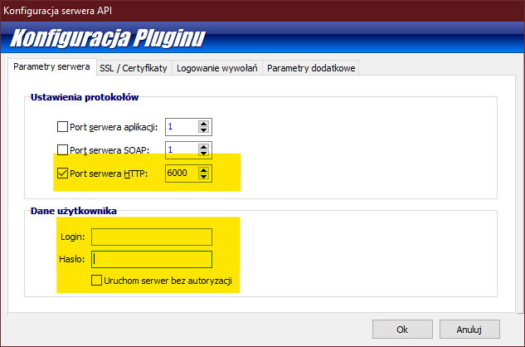
- Port serwera HTTP (HTTP server port) – API supports the HTTP protocol only. Enter the port number you want to be used by the API service.
- Login i Hasło (Login and password) – authorization data to access the API.
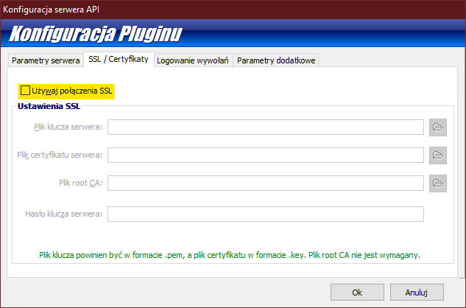
- Używaj połączenia SSL (Use SSL connection) – check this option and select a certificate to use a secure connection to the API.
  - Plik klucza serwera – a server key in the PEM file format;
  - Plik certyfikatu serwera – a server certificate in the KEY file format;
  - Plik root CA – a root CA file (optional);
  - Hasło klucza serwera – a server key password;
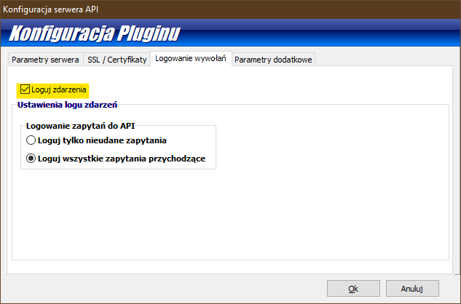
Events logging options:
- Loguj zdarzenia (Log events) – this option enables logging different events by the server. The options allow for logging only unsuccessful requests (Loguj tylko nieudane zapytania) or logging all the incoming requests (Loguj wszystkie zapytania przychodzące).

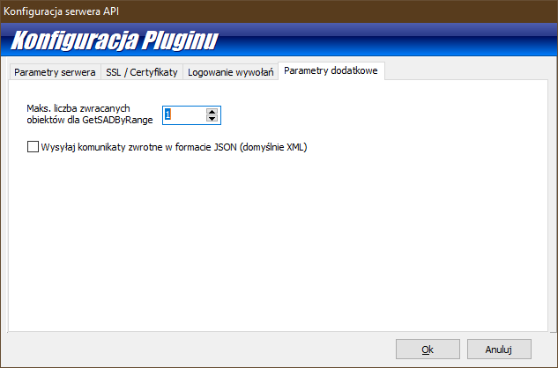

Additional options:
- Maks. liczba zwracanych obiektów dla GetSADByRange (Max. number of objects returned by GetSADByRange) – this option is used to restrict the number of objects returned by the GetSADByRange method (see the 5.1.4 section for more information).
- Wysyłaj komunikaty zwrotne w formacie JSON (domyślnie XML) (Respond to the incoming requests in JSON format (default XML)) – this option allows the server to send responses in JSON format.

WinSAD Service configuration
Start WinSAD to configure it to work in service mode.

ATTENTION! The application working in service mode uses one license of the WinSAD application.

Select Twórz opcje dla trybu usług WinSAD (Create configuration for WinSAD service) from the Narzędzia\Narzędzia administratora menu.

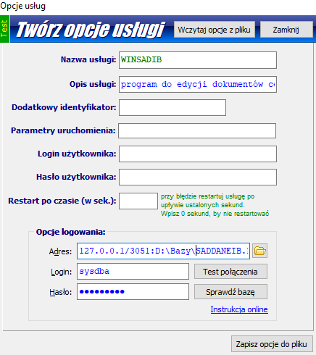

Parameters available in the configuration dialog:
- Opis usługi (Service description) – a description of the service to be displayed on the Windows services list.
- Dodatkowy identyfikator (Additional identifier) – fill this box if you intend to run more than one WinSAD service in a single Windows system environment; allows to distinguish the services.
- Parametry uruchomienia (start-up parameters) – a list of parameters used to start the service, same as the parameters used when running WinSAD in application mode.
- Login użytkownika i Hasło użytkownika (User login and User password) – credentials of the WinSAD user used to run WinSAD in service mode. It is recommended to create a dedicated WinSAD user account, which will act as a service account. When the service account is created, start WinSAD in application mode and log in as the service user to complete the configuration of the service user profile in WinSAD. ATTENTION! This is a user of Huzar Software application, not the Windows account used to run the service.

After saving the service configuration to a file, WinSAD will suggest creating a desktop shortcut to the WinSAD service management console.

Running WinSAD as a service
Using the shortcut created in 3.2, start the WinSAD service management console as system administrator and select Uruchom jako usługę from the Tryb pracy menu.

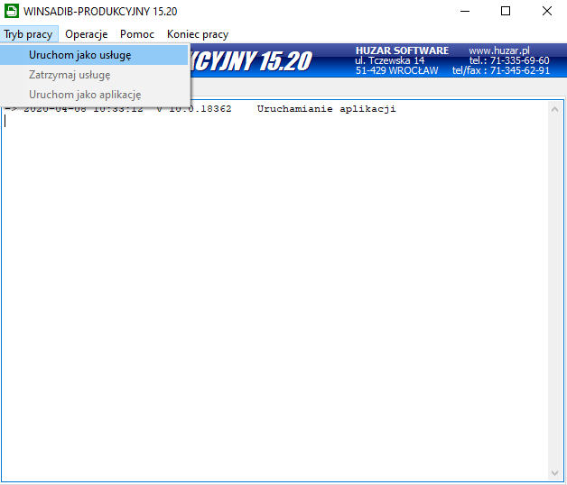

In the Dane usługi NT dialog, which will be displayed, select the user account to be used to start the WinSAD service. If the privileges of the Windows technical accounts are not sufficient, create a new user account in the system, select the Inne konto option and complete the Nazwa konta (Account name) and Hasło dostępu (Password) fields.

HuzarAPI installation test
To check if the service is working properly, start any web browser and enter a sample query:

http://127.0.0.1:3012/~HUZARAPI/GETSAD?IDSAD=1
The above request works for a sample configuration specified in section 3.1. You should adjust it to your own configuration by entering the correct protocol (http or https) and port number. The elements of the address to be customized are underlined.

A properly configured and running API should result in getting the above request:
Returns a message if the SAD of ID=1 does not exist in the WinSAD application database
Brak SAD-u o ID: 1
or the SAD of ID=1 in WinSAD application database (if it exists) in DeclarationList format.

HuzarAPI for SADs and temporary storage with http protocol

The API allows you to call a specific set of functions of WinSAD application. To obtain data from WinSAD database, http requests use GET (reading data from the database) and POST (writing data to the database) methods.
If # or @ special characters are present in the request parameters, they must be replaced by the corresponding codes:
- instead of # the code %23 should be used
- instead of @ the code %40 should be used
The # and @ characters may occur in document GUIDs requested from the database.

Methods using http GET
Requests using GET method are performed by calling specific functions with parameters in HuzarAPI. Below you will find the list of available functions.

GETSAD
Function description:
Reads a SAD document from the database based on the given criteria (parameters).
Input parameters:
- IDSAD type: integer
- DOCREFNO type: text
- GUID type: text
Output:
XML / JSON object of DeclarationList type or an error message.

GETSADSTATUS
Function description:
Reads the status of a SAD document based on the given criteria.
Input parameters:
- IDSAD type: integer
- DOCREFNO type: text
- GUID type: text
Output:
The status of the SAD as an integer value.
Possible SAD statuses:
-1 – Unknown – returned in case of error or unsupported status;
10 – Preparing – a document in preparation – it has been created and may be modified by the user;
20 –Sent – the document has been sent to the customs system and is awaiting approval;
30 – Confirmed – the document has been approved by the customs and is awaiting clearance;
40 – Control – the document has been detained for customs control by the customs office;
50 – Rejected – the document has been rejected by the customs office;
60 – Annulled – the document has been annulled on the request of the sender;
70 – Cleared – the document has been cleared to the requested customs procedure;
80 – Closed – the document has been closed (for export IE599 and for transit IE029 has been received).
- – Mixed – different statuses within a single SAD

COPYSAD
Function description:
Creates a copy of the document indicated as a source in the input parameter. The copy is created according to the options of the WinSAD user whose account is used for the HuzarAPI service.
Input parameters:
- IDSAD type: integer
- DOCREFNO type: text
- GUID type: text
Output:
An XML / JSON object of DeclarationList type containing data of the newly created document.

GETSADBYRANGE
Function description:
Reads the list of SADs using the given criteria.
Input parameters:
- FROM type: date – date of the SAD document (start date)
- TO type: date – date of the SAD document (end date)
- BRANCHID type: text [3] (3 characters) – the ID of the branch to which the SAD is assigned
- LASTCHANGEID type: integer – identifier of the last change in the SAD document, all documents for which the change id is higher than the given parameter will be returned.
- DECLTYPE type: text [1] (declaration type – “I” import/ “E” export/” T” transit
- HEADERONLY type: boolean – possible values “true” or “false” – if the parameter is not given the value is defaulted as “false”. The parameter indicates whether the header data only or the complete declaration is to be returned (without or with declaration items and invoice items).
- SADSTATUS type: integer – code based on SAD document’s status;
possible codes are described in section 5.1.2.
Output:
An XML / JSON object of DeclarationList type containing all the declarations matching the criteria given in input. In the Declaration.HSChangeID attribute returned in DeclarationList there is a new value of the last change id returned. HSChangeID is not filled, if it has not been given in input parameters.
To use the functionality of last change id, you need to enable logging of changes in WinSAD. To do that, from WinSAD main menu, select Opcje\Opcje programu, go to the Zapis w bazie – wspólne section and check the Zapisz zmiany danych SAD-u w module historii zmian option.
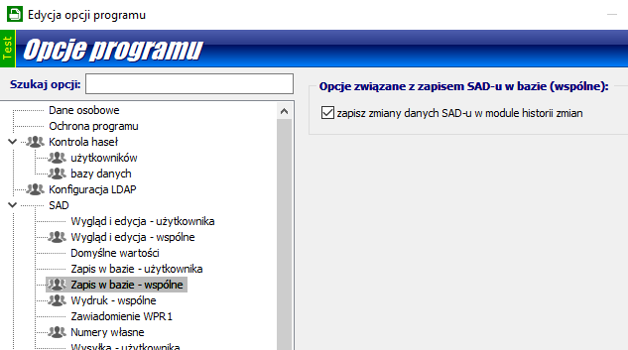

From that moment on, every change in the SAD documents will be logged in the database and you will be able to use the last change id as the function parameter.
Due to the possibility of including multiple SAD documents in the output of the function, the number of returned documents may be limited in the module options to avoid large amount of data contained in a single request. To do that, in the configuration of the HuzarAPI module, you should specify the value of the Maks. liczba zwracanych obiektów dla GetSADByRange parameter.

GETATTACHEDDOCLIST
ATTENTION! The GETATTACHEDDOCLIST function can only be used if the following conditions are met:
- An additional module called Składnica Dokumentów (Document Storage) is enabled and configured in WinSAD,
- Saving of customs documents to Składnica Dokumentów and attaching them to SADs is enabled in WinSAD configuration.
To obtain access to module Składnica Dokumentów please contact Huzar Software.
Function description:
Gets a list of documents attached to the SAD document. Documents are stored on 2 levels in WinSAD: documents and attachments. The list in the output contains a flat list of all attachments for a given SAD.
In case of multi-set SAD documents, each set will contain the same list of documents (there is no information to which set a document is attached to).
Input parameters:
- IDSAD type: integer
- DOCREFNO type: text
- GUID type: text
Output:
An XML / JSON object of AttachedDocumentList type containing a list of all attachment headers for a given SAD document.

GETATTACHEDDOCDET
Function description:
Gets a specific document attached to the SAD. The return value of the function contains a base64 encoded string in AttachedDocument type.
Input parameters:
- GUID type: text (GUID of the document)
Output:
An XML / JSON object of AttachedDocumentList type containing a single document encoded in base64.

GETCUSTOMSMSGLIST
Function description:
Gets customs messages attached to the customs declaration. The return value of the function contains a base64 encoded string in ListCustomsMSG type.
Input parameters:
- DBID type: integer
- DOCREFNO type: text
- GUID type: text (GUID of the document)
- MRN type: text
- MSGTYPE type: integer (list of values attached separately)
- DOCTYPE type: integer (default 0 = „SAD”)

Output:
An XML / JSON object of ListCustomsMSG type containing a list of CustomsMSG, which holds a document encoded in base64. Additionally, the type holds basic information about the document, namely: CustomsRefNo (customs reference number), IDSAD (dbID), MSGType (document type).

MSGTYPE - allowed values:
AES+ | AES PoUS | NCTS+ | AIS+
CC504C = 3000 | IEP01 = 3100 | IE004PL = 4000 | CC404A= 5000
CC507C = 3001 | IEP03 = 3101 | IE007PL = 4001 | CC410A = 5001
CC507B = 3002 | IEP04 = 3102 | IE009PL = 4002 | CC413A = 5002
CC509C = 3003 | IEP17 = 3103 | IE013PL = 4003 | CC414A = 5003
CC511C = 3004 | IEP19 = 3104 | IE014PL = 4004 | CC415A = 5004
CC513C = 3005 | IEP23 = 3105 | IE015PL = 4005 | CC426A = 5005
CC514C = 3006 | IEP30 = 3106 | IE019PL = 4006 | CC428A = 5006
CC515C = 3007 | IEP32 = 3107 | IE022PL = 4007 | CC429A = 5007
CC521C = 3008 | IEP38 = 3108 | IE025PL = 4008 | CC431A = 5008
CC522C = 3009 | IEP46 = 3109 | IE028PL = 4009 | CC432A = 5009
CC525C = 3010 | IEP560 = 3110 | IE029PL = 4010 | CC438A = 5010
CC528C = 3011 | SRD = 3111 | IE035PL = 4011 | CC444A = 5011
CC529C = 3012 |  | IE043PL = 4012 | CC446A = 5012
CC531C = 3013 |  | IE044PL = 4013 | CC447A = 5013
CC547C = 3014 |  | IE045PL = 4014 | CC451A = 5014
CC548C = 3015 |  | IE054PL = 4015 | CC456A = 5015
CC551C = 3016 |  | IE051PL = 4016 | CC460A = 5016
CC556C = 3017 |  | IE055PL = 4017 | DS404 = 5017
CC557C = 3018 |  | IE056PL = 4018 | DS410 = 5018
CC560C = 3019 |  | IE057PL = 4019 | DS413 = 5019
CC561C = 3020 |  | IE060PL = 4020 | DS414 = 5020
CC566C = 3021 |  | IE140PL = 4021 | DS415 = 5021
CC570C = 3022 |  | IE141PL = 4022 | DS428 = 5022
CC571C = 3023 |  | IE170PL = 4023 | DS446 = 5023
CC573C = 3024 |  | IE182PL = 4024 | DS460 = 5024
CC574C = 3025 |  | IE906PL = 4025 | DSX16 = 5025
CC582C = 3026 |  | IE917PL = 4026 | DSX18 = 5026
CC583C = 3027 |  | IE928PL = 4027 | DSX19 = 5027
CC590C = 3028 |  | IE280PL = 4028 | DSX22 = 5028
CC599C = 3029 |  | IE029SC = 4029 | DSX30 = 5029
CC604C = 3030 |  |  | DSX99 = 5030
CC609C = 3031 |  |  | PP428 = 5031
CC613C = 3032 |  |  | PP446 = 5032
CC614C = 3033 |  |  | PP460 = 5033
CC615C = 3034 |  |  | PPX01 = 5034
CC628C = 3035 |  |  | PPX02 = 5035
CC906C = 3036 |  |  | PPX03 = 5036
IEM529C = 3037 |  |  | PPX16 = 5037
IE5ST1 = 3038 |  |  | PPX26 = 5038
IE5ST2 = 3039 |  |  | PPX32 = 5039

DOCTYPE - allowed values:
SAD = 0
SATOS = 12
WDS+ = 17
AES PoUS = 20
DSAIS+ = 21
ICS2 = 23

GETGENERATEDDOCLIST
Function description:
Gets a list of documents generated from the SAD. The return value of the function contains document ID, type, and number in ListGeneratedDoc type.
Input parameters:
- IDSAD type: integer
- DOCREFNO type: text
- GUID type: text (GUID of the document)
- MRN type: text
- MSGTYPE type: integer
- CMR
- EUR.1
- Cert. of origin
- A.TR
Output:
An XML / JSON object of ListGeneratedDoc type containing a list of GeneratedDoc, which holds values DocID (document ID), DocType (document type), and DocNo (document number).

GETREPRESENTATION
Function description:
Gets representations specified by provided parameters. The return value of the function contains all found representations as a list of RepresentationList type.
Input parameters:
- NIP type: string
- LASTCHANGEID type: integer
- TYPE type: integer
- TYPEOFVALIDITY type: integer
- ONLYVALID type: boolean
At least one of the parameters [NIP, LASTCHANGEID] is required.
Values for fields TYPE and TYPEOFVALIDITY are listed in attached excel file
“HuzarAPI_Formats_v_X_XX.xlsx”.
Output:
An XML / JSON object of RepresentationList type containing a list of Representation type, which holds essential information such as: number, type, type of validity, validity timeframe, revoked/deleted flags, last change date and ID, company.

GETDELIVERIES
Function description:
Gets MagCS deliveries specified by provided parameters. The return value of the function contains all found deliveries as a list of DeliveryList type.
Input parameters:
- BRANCHID type: string
- DELIVERYID type: integer
- LASTCHANGEID type: integer
- FROM type: date
- TO type: date
- HEADERONLY type: boolean
At least one of the parameters [BRANCHID, DELIVERYID, LASTCHANGEID] is required.
If HEADERONLY is set to true, then the function will omit listing shipments.
Output:
An XML / JSON object of DeliveryList type containing a list of Delivery type, which holds essential information such as: UID, delivery number, date of arrival, LastChangeID, deletion status, transportation info, and conditionally deliveries’ shipments.

SENDSAD
Function description:
Submits a task of sending a declaration to the polish customs system. The return value of the function informs whether the task was scheduled or not.
Input parameters:
- IDSAD type: integer
- DOCREFNO type: text
- GUID type: text (GUID of the document)
- MRN type: text
- USER type: string
- EXPORTTYPE type: integer
  - WebService channel
  - E-mail channel
- GATEWAY type: integer
- PUESC v1
- PUESC v2
- BCP
- BCP e-Commerce
- THUMB type : string
Required parameters: one of [IDSAD, DOCREFNO, GUID, MRN]; USER; EXPORTTYPE; GATEWAY.
Output:
Declaration ID if the task was scheduled successfully, an error message otherwise.

Methods using http POST
For functions using the http POST method, the parameter(s) are enclosed in the BODY element of the request.

ADDSAD
Function description:
Adds new documents to WinSAD database. Some data will be deleted before saving the document to meet the technical requirements of a new document in WinSAD.
Input parameters:
- BODY type: DeclarationList
Output:
The request returns a DeclarationList object completed with technical data (Huzar dbID, GUID of the document, etc.)
Remarks:
- The SAD document can be created in two different modes – based on given DeclItems (items of the SAD declaration) or Invoices (invoices and invoice items). In one function call it is not possible to give both types of lists – if they are given simultaneously an error will be returned. The SAD created based on invoices will be created in the “based on invoices” mode and items of the customs declaration will be created based on parameters given in GroupingOptions node. If DeclItems are enclosed in the message, the document will be created in “manual” mode and the declaration items will exactly reflect the data sent in the input parameter to the function.
- In the “based on invoices” mode, the ItemSyncOptions node can be added which will cause synchronization of invoice items with items master data in WinSAD.
- You can attach document scans (like invoices, specifications, proofs) to the SAD document using the Attachments section.

ADDDELIVERY
Function description:
Adds a new delivery to MagCS. The function returns all added deliveries as a list of DeliveryList type.
Input parameters:
- BODY type: DeliveryList
Output:
The request returns a DeliveryList object completed with technical data (Huzar dbID, GUID of the delivery etc.)

HuzarAPI z protokołem HTTP dla modułu SENT
The API allows you to call a specific set of functions of SENT module. To obtain data from SENT database, http requests use GET (reading data from the database) and POST (writing data to the database) methods.
If # or @ special characters are present in the request parameters, they must be replaced by the corresponding codes:
- instead of # the code %23 should be used
- instead of @ the code %40 should be used
The # and @ characters may occur in document GUIDs requested from the database.

Methods using http GET
Requests using GET method are performed by calling specific functions with parameters in HuzarAPI. Below you will find the list of available functions.

GETSENT
Function description:
Reads a SENT message from the database based on the given criteria (parameters).
Input parameters:
- IDSENT type: integer
- GUID type: text
- ORDERNO type: text
- SENTNO type: text
- DOCID type: text

Output:
XML / JSON object of SENTDeclList type or an error message.

GETSENTSTATUS
Function description:
Reads the status of a SENT message based on the given criteria.
Input parameters:
- IDSENT type: integer
- GUID type: text
- ORDERNO type: text
- SENTNO type: text
- DOCID type: text
Output:
The status of the SENT as an integer value.
Possible SAD statuses:
0 – In preparation;
1 – Sent;
2 – Declined;
3 – Cancelation sent;
4 – Cancellation rejected;
5 – Query on transport data sent;
6 – Query on transport data rejected;
7 – Data update sent;
8 – Data update rejected;
9 – Closure sent;
10 – Closure rejected;
11 – Request on new authorisation keys;
12 – Request on new authorisation keys rejected;
13 – Pending

GETSENTNUMBER
Function description:
Reads the SENT number based on given criteria.
Input parameters:
- IDSENT type: integer
- GUID type: text
- ORDERNO type: text
- DOCID type: text

Output:
A string with the SENT number or an error message.

GETSENTBYRANGE
Function description:
Reads a list of SENT messages using the given criteria.
Input parameters:
- FROM type: date – SENT movement date (date from)
- TO type: date – SENT movement date (date to)
- BRANCHID type: text [3] (3-letter branch/department ID)
- LASTCHANGEID type: liczba całkowita - – identifier of the last change in the SENT document, all documents for which the change id is higher than the given parameter will be returned.
- SENTSTATUS type: integer – code based on SENT document’s status;
possible codes are described in section 6.1.2.

Output:
An XML / JSON object of SENTDeclList type containing all the declarations matching the criteria given in input. In the HSDBChangeID attribute returned in SENTDeclList there is a new value of the last change id returned. HSDBChangeID is not filled, if it has not been given in input parameters.
To use the functionality of last change ID, you need to enable logging of changes in module SENT in menu “Moduły/Historia zmian”. Changes in SENT documents are written in the database and last change returned is returned via the ID of this change in the database.
Because multiple SENT documents may be returned, in the module configuration you can limit the number of returned documents. To do that in the configuration of HuzarAPI you need to define the parameter Maks. liczba zwracanych obiektów dla GetSENTByRange.

GETSENTKEY
Function description:
Reads SENT keys.
Input parameters:

- CONSIGNEEKEY – returns consignee key
- CONSIGNORKEY – returns consignor key
- CARRIERKEY – returns carrier key
- [none] - If the parameter is not provided, all keys will be returned

- IDSENT type: integer
- GUID type: text
- ORDERNO type: text
- DOCID type: text
- SENTNO type: text

Output:
You can mix and match the parameters to retrieve any combination of keys CONSIGNEEKEY/CONSIGNORKEY/CARRIERKEY. If you request a single key, the response will return only that key. If you request multiple keys, the response will be returned as an XML or JSON structure containing all the requested keys. If no parameters are provided, the system will return all available keys.

Metody wykorzystujące http POST
For functions using the http POST method, the parameter(s) are enclosed in the BODY element of the request.

ADDSENT
Function description:
Adds new documents to SENT database. Some data might be deleted before saving the document to meet the technical requirements of a new document in HuzarSENT.
Input parameters:
- BODY type: SENTDeclList
Output:
The request returns a SENTDeclList object completed with technical data (Huzar dbID, GUID of the document, etc.)

HUZARAPI Z PROTOKOŁEM HTTP DLA MODUŁU BAZY FIRM
The API allows you to call a specific set of functions of Companies database. It allows management of companies and attached to them details such as representations.

METODY WYKORZYSTUJĄCE HTTP POST
For functions using the http POST method, the parameter(s) are enclosed in the BODY element of the request.

ADDCOMPANY
Function description:
Adds or updates a company in the database.
Input parameters:
- BODY type: CompanyList
Output:
Function returns CompanyList completed with technical data (e.g. GUID, Huzar dbID).

UPDATECOMPANY
Function description:
Update of a company already existing in the database.
Input parameters:
- BODY type: CompanyList (with field GUID or Huzar dbID filled to search the database for the company to update)
- KEYFIELD (defines the key type field which is used to search the database for a company for update) – possible values: „COMPANYID” and „ADDITIONALID”
- UPDATEONLYINCOMINGFIELDS - allows updating only the fields specified in the request body. If this parameter is included in the request, the system will update only the provided fields, leaving the rest unchanged. If the parameter is not included, all fields will be updated, and any fields not present in the request will be removed from the database.
Output:
Function returns CompanyList completed with technical data (e.g. GUID, Huzar dbID).

ADDREPRESENTATION
Function description:
Adds a representation to an existing company in the database. The company data to which the representation is to be attached may be given in the input parameters of the http request or directly in the Representation type (in that case the COMPANYID and ADDITIONALID are not mandatory in the call)
Input parameters:
- GUID type: text (GUID of the company)
- COMPANYID type: text (Company ID – short description)
- ADDITIONALID type: text (Additional company ID – additional short description)
- BODY type: RepresentationList
Output:
Function returns RepresentationList completed with technical data (e.g. Huzar dbID).

UPDATEREPRESENTATION
Function description:
Update of an existing representation in the Companies database. Company data to which the representation. The company data to which the representation is to be attached may be given in the input parameters of the http request or directly in the Representation type (in that case the COMPANYID and ADDITIONALID are not mandatory in the call).
Input parameters:
- GUID type: text (GUID of the company)
- COMPANYID type: text (Company ID – short description)
- ADDITIONALID type: text (Additional company ID – additional short description)
- BODY type: RepresentationList
Output:
Function returns RepresentationList completed with technical data (e.g. Huzar dbID).

ADDAUTHORIZATION
Function description:
Adds an authorization to an existing company in the database. The company data to which the authorization is to be attached may be given in the input parameters of the http request or directly in the Authorization type (in that case the COMPANYID and ADDITIONALID are not mandatory in the call).
Input parameters:
- GUID type: text (GUID of the company)
- COMPANYID type: text (Company ID – short description)
- ADDITIONALID type: text (Additional company ID – additional short description)
- BODY type: AuthorizationList
Output:
Function returns AuthorizationList completed with technical data (e.g. Huzar dbID).

UPDATEAUTHORIZATION
Function description:
Update of an existing authorization in the Companies database. Company data to which the representation. The company data to which the authorization is to be attached may be given in the input parameters of the http request or directly in the Authorization type (in that case the COMPANYID and ADDITIONALID are not mandatory in the call).
Input parameters:
- GUID type: text (GUID of the company)
- COMPANYID type: text (Company ID – short description)
- ADDITIONALID type: text (Additional company ID – additional short description)
- BODY type: AuthorizationList
Output:
Function returns AuthorizationList completed with technical data (e.g. Huzar dbID).

Data formats
In order to communicate with external systems, appropriate data formats have been prepared. These formats are mapped to objects used internally in Huzar Software applications. The structure and description of the possible messages can be found in the attached HuzarAPI_Formats_v_X_XX.xlsx file.

Customs declaration list
This format is used to transfer customs declaration data. By default, it is always sent as a list of documents. If a Huzar system document is a multiset document (i.e. the declaration created on the basis of an invoice contains more declaration items than the maximum number allowed for the customs system), the return value for the function will contain multiple declarations with a single Huzar Software identifier.

Documents attached to Customs declaration
Format containing details of documents attached to the customs document. These are usually documents read from the Składnica Dokumentów module. In case of proper configuration of WinSAD and Składnica Dokumentów (described above) it is possible to obtain the customs messages that are related to a SAD document.

Examples
Below you can find examples of requests and their descriptions:

GETSAD

Declaration with a certain ID
Request returning the customs declaration with WinSAD database ID 55753
http://127.0.0.1:3012/~HUZARAPI/GetSAD?IDSAD=55753
If the declaration exists, the return value will be enclosed in the BODY element of the message as an XML / JSON e.g.:

Error message
If the SAD document does not exist, the BODY element contains the message:
Brak SAD-u o ID: 55753

GETSADBYRANGE

Date range
The below request will return a list of customs documents from the given date range – in this example declarations from 2020.04.01 to 2020.04.20

http://127.0.0.1:3012/~HUZARAPI/GetSADByRange?FROM=20200401&TO=20200420

In the BODY element of the message you will get XML data e.g.:

,

Headers
To obtain document headers only, without detailed information of declaration items, the request for the same date range as above is as follows:
http://127.0.0.1:3012/~HUZARAPI/GetSADByRange?FROM=20200401&TO=20200420&HEADERONLY=True
In the BODY element of the message the response contains XML / JSON data e.g.:

Last changes
To get a list of last changes for customs declarations, you have to enable the history of changes in WinSAD (as described above). In the input parameter, enter the identifier of the last change that was registered in your system (all changes with the higher change ID will be returned)
http://127.0.0.1:3012/~HUZARAPI/GetSADByRange?LASTCHANGEID=19587
In the BODY element of the message the response contains XML / JSON data e.g.:
Please note that each document on the list will have the same HSDBChangeID, which refers to the last change returned. In case of subsequent requests, this identifier must be entered in the next request to obtain the next set of database changes.

Error message
If the list is empty, the BODY part will contain the text:
Nie udało się wczytać obiektów SAD

GETSADSTATUS

Request on the SAD status
Request on the SAD status with customs reference number 19S116O10U:
http://127.0.0.1:3012/~HUZARAPI/GetSADSTATUS?DOCREFNO=19S116O10U

In the BODY part of the message you will get a return value as below:

GETCUSTOMSMSGLIST

Request on the SAD customs msg list
Request on the SAD customs MSG list with customs reference number 19S116O10U:
http://127.0.0.1:3012/~HUZARAPI/GetCUSTOMSMSGLIST?DOCREFNO=19S116O10U

In the BODY part of the message you will get a return value as below:

GETGENERATEDDOCLIST

Request on the SAD generated docs
Request on the SAD generated documents list with customs reference number 19S116O10U:
http://127.0.0.1:3012/~HUZARAPI/GetGENERATEDDOCLIST?DOCREFNO=19S116O10U

In the BODY part of the message you will get a return value as below:

GETREPRESENTATION

Request on the company’s representations
Request on the company’s representation list with NIP number 1234567890:
http://127.0.0.1:6000/~HUZARAPI/GETREPRESENTATION?NIP=1234567890

In the BODY part of the message you will get a return value as below:

GETDELIVERIES

Request on MagCS deliveries
Request on the delivery list with LASTCHANGEID equal to 0:
http://127.0.0.1:6000/~HUZARAPI/GETDELIVERIES?LastChangeID=0
In the BODY part of the message you will get a return value as below:

SENDSAD

Request on sending a declaration
Request on sending a declaration of ID 3469 through the e-mail channel and BCP gate via user Test1:
http://127.0.0.1:6000/~HUZARAPI/SENDSAD?IDSAD=3469&USER=Test1&EXPORTTYPE=1&GATEWAY=3
In the BODY part of the message you will get a return value as below:

ADDSAD

Request on adding a declaration
Request on adding a declaration:
http://127.0.0.1:6000/~HUZARAPI/ADDSAD
In the request BODY a document in the Declaration format has to be sent (examples below):
SAD  [manual] |  |  | SAD AIS H7  [manual]
SAD with company DB  [manual] |  |  | SAD AIS H7 OISS  [manual]
SAD  [invoice based] |  |  | SAD AIS H7 OISS  [invoice based]

In the BODY part of the message you will get a return value as below:

ADDDELIVERY

Request on adding a delivery with shipments
Request on adding a delivery:
http://127.0.0.1:6000/~HUZARAPI/SAD/ADDDELIVERY

In the request BODY a document in the Delivery format has to be sent (examples below):
In the BODY part of the message you will get a return value as below:

GETSENT

Request on a SENT document
Request on a SENT document:
http://127.0.0.1:3012/~HUZARAPI/SENT/GETSENT
In the BODY part of the message you will get a return value as below:

GETSENTSTATUS

Request on the status of a SENT document
Request on the status of a SENT document:
http://127.0.0.1:3012/~HUZARAPI/SENT/GETSENTSTATUS?IdSENT=336
In the BODY part of the message you will get a return value as below:

GETSENTNUMBER

Request on SENT number
Request on SENT number:
http://127.0.0.1:3012/~HUZARAPI/SENT/GETSENTNumber?IdSENT=255
In the BODY part of the message you will get a return value as below:

GETSENTBYRANGE

Request on SENT documents from a given range
Request on SENT documents from a given range:
http://127.0.0.1:3012/~HUZARAPI/SENT/GETSENTBYRANGE?FROM=20230111&TO=20240111
In the BODY part of the message you will get a return value as below:

GETSENTKEY

Request on SENT keys
Request on SENT keys:
http://127.0.0.1:3012/~HUZARAPI/SENT/GETSENTKey?IDSENT=601&CARRIERKEY&CONSIGNEEKEY
In the BODY part of the message you will get a return value as below:

ADDSENT

Request on adding a SENT document
Request on adding a SENT document:
http://127.0.0.1:3012/~HUZARAPI/SENT/ADDSENT
In the BODY part of the message you need to send a SENTDecl object:
In the BODY part of the message you will get a return value as below:

ADDCOMPANY

Request on adding a company
Request on adding a company:
http://127.0.0.1:3012/~HUZARAPI/Company/ADDCOMPANY
In the BODY part of the message you need to send a Company object:
In the BODY part of the message you will get a return value as below:

UPDATECOMPANY

Request on updating company data
Request on updating company data:
http://127.0.0.1:3012/~HUZARAPI/Company/UpdateCompany?AdditionalID=Tczew1&KeyField=AdditionalID
In the BODY part of the message you need to send a Company object:
In the BODY part of the message you will get a return value as below:

ADDREPRESENTATION

Request on adding a representation
Request on adding a representation:
http://127.0.0.1:3012/~HUZARAPI/Company/ADDREPRESENTATION?CompanyId=HUZAR
In the BODY part of the message you need to send a Representation object:
In the BODY part of the message you will get a return value as below:

UPDATEPRESENTATION

Request on updating representation data
Request on updating representation data:
http://127.0.0.1:3012/~HUZARAPI/Company/UPDATEREPRESENTATION?CompanyId=HUZAR
In the BODY part of the message you need to send a Representation object:
In the BODY part of the message you will get a return value as below:

ADDAUTHORIZATION

Request on adding an authorization
Request on adding an authorization:
http://127.0.0.1:3012/~HUZARAPI/Company/ADDAUTHORIZATION?CompanyId=HUZAR
In the BODY part of the message you need to send an Authorization object:
In the BODY part of the message you will get a return value as below:

UPDATEAUTHORIZATION

Request on updating authorization data
Request on updating authorization data:
http://127.0.0.1:3012/~HUZARAPI/Company/UPDATEAUTHORIZATION?CompanyId=HUZAR
In the BODY part of the message you need to send an Authorization object:
In the BODY part of the message you will get a return value as below:

